

University of Engineering & Technology Mardan
Department of Computer Software Engineering

Submitted By | Umar Hayat
Semester | 6th, Spring 2026
Registration No | 23MDSWE274
Batch | 06
Subject | HCI Lab
Submitted To | Dr. Hamid Ullah
Lab Task # 03

Objective: To redesign poorly designed software interfaces identified in the previous lab by applying HCI principles to make them clutter-free and user-friendly.

Task 1: Certificate Desktop Application
Problem: The original app uses a single hidden scroll bar. You can only see one design at a time, making it almost impossible to find the same certificate again later.
Redesign: I changed it to a grid gallery view. Now, multiple thumbnails are visible at once, and there are search filters and categories (like Academic or Corporate) so users can easily recognize and find templates.

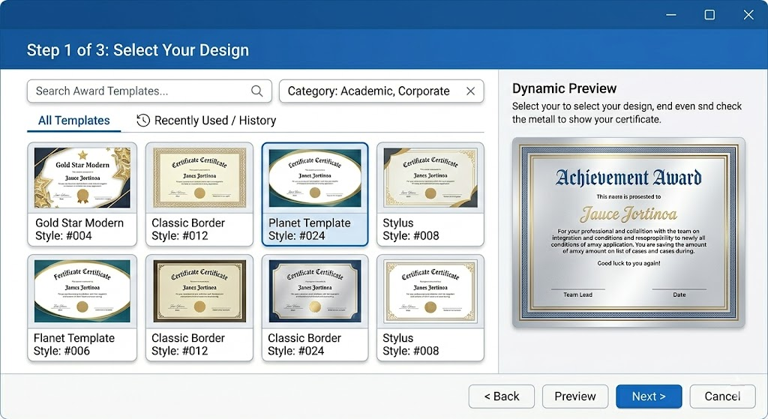

Task 2: Pizza Ordering Checkout
Problem: The system forces registered users to re-enter their city, branch, and phone number. The "area" dropdown only has one option, which is redundant. Additionally, the final checkout and "add to cart" functionalities lack clear visual cues or weren't working smoothly.
Redesign: I used "smart defaults" to auto-fill the user's saved city and phone number. I completely removed the useless area dropdown. Finally, I redesigned the checkout and add-to-cart buttons to be prominent and clearly actionable.

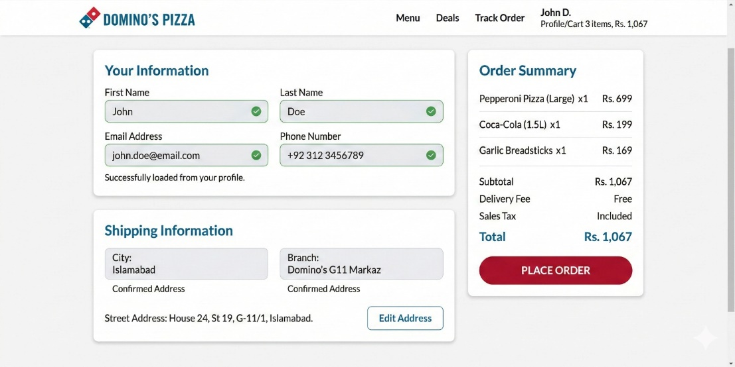

Task 3: Kids Clothing Website
Problem: Shoppers need to see size, price, and material immediately without clicking through multiple menus.
Redesign: I designed a clean desktop e-commerce interface focused on fast decision-making through strong visual hierarchy.
Size options use interactive pill buttons, with out-of-stock sizes grayed out and struck through.
Fabric details are shown using simple icons (e.g., a green leaf for 100% cotton) instead of long text.
A “Quick View” side panel lets users see details and add items without leaving the grid.
Price and “Add to Cart” are the most visually prominent elements to reduce cognitive load.

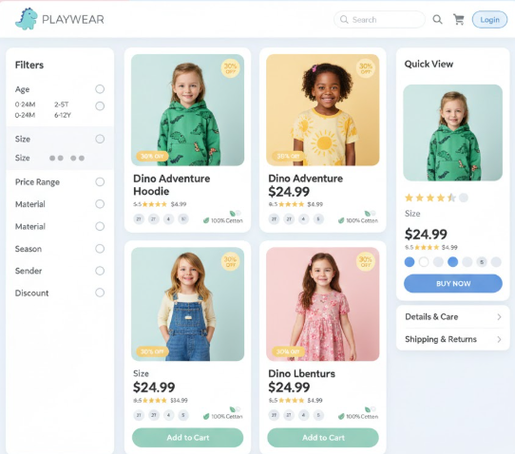

Task 4: Admissions Portals Redesign
For this task, I focused on the two systems compared in our previous assignment.
1. NUST Admissions Page (The Redesign) Problem: The original site has huge walls of text, confusing data tables for dates, and forces students to print a manual bank challan.
Redesign: I cleared the text walls and created a clean, 3-step visual roadmap. I also added a digital payment section so the entire process, including the fee, is handled online.
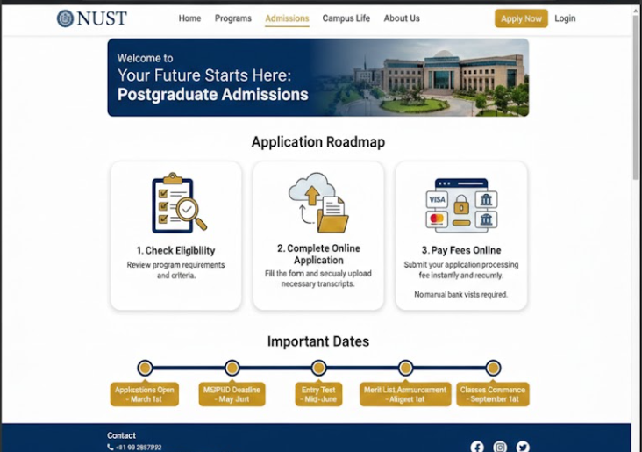

2. National University (USA) Admissions Page (The Benchmark) Why it works: This is the ideal interface. It uses a lot of white space, simple step-by-step guidance, and an integrated digital portal. Students can check requirements, track status, and pay fees in one unified place without getting lost in nested menus.
